**JIRA**

**Jira Tool**

Test Management Tools

Bugs Reporting & Tracking Tools

Agile Tools 🡪Jira, VersionOne, Teamcity……

Jira 🡪Agile Management Tool

Cloud :

🡪Pro(Licensed)

🡪Free version: 10 users/ 30days

Link: <https://www.atlassian.com/software/jira/free>

**Agile scrum activity**

1.How to create a project in jira.

2.How to add users/people in jira.

3.How to create Backlog 🡪 Epic.

Backlog🡪 Epic🡪 stories

Create spint 🡪 Add stories to the sprint 🡪 Add task for every story

4.How to create stories in Jira & add story points.

5.creating sprint in Jira

6.Adding user stories to sprint

7.starting sprint.

8.Adding sub-tasks to story.

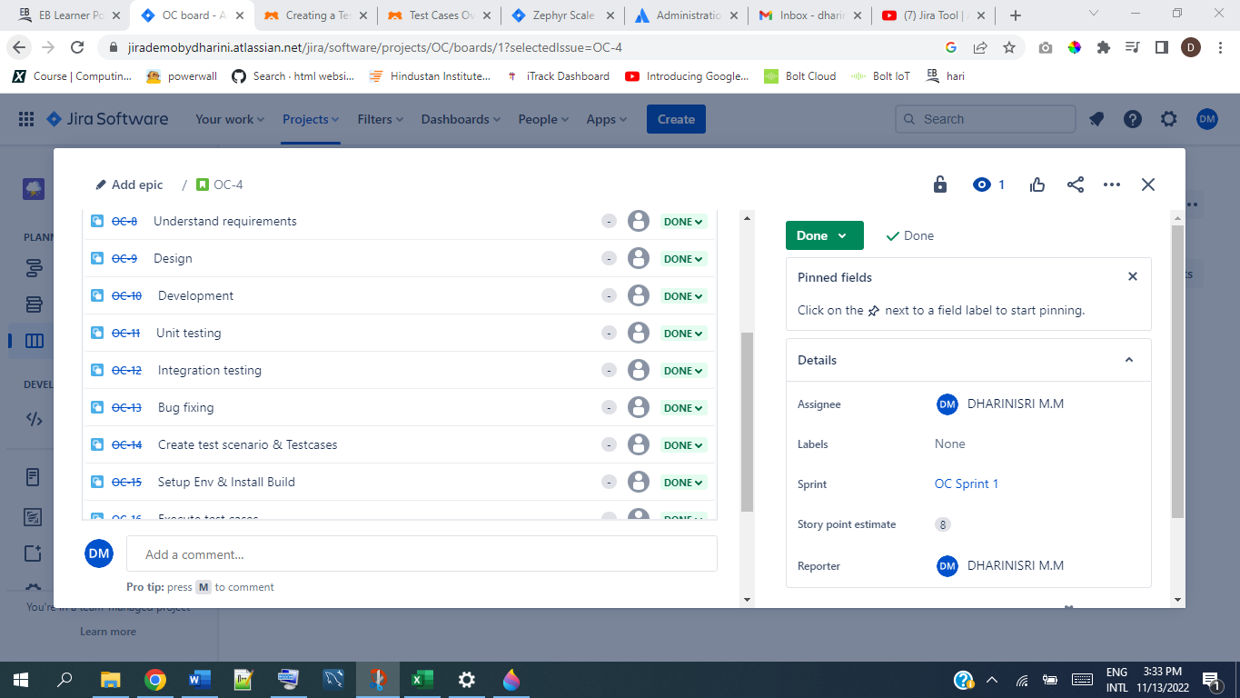

9.Sprint life cycle.

Test management Activities(zepyre)

🡪Test cases

🡪Test cycle

🡪update test cases passed/failed/blocked

🡪Reports

1.How to install zephyr plugin

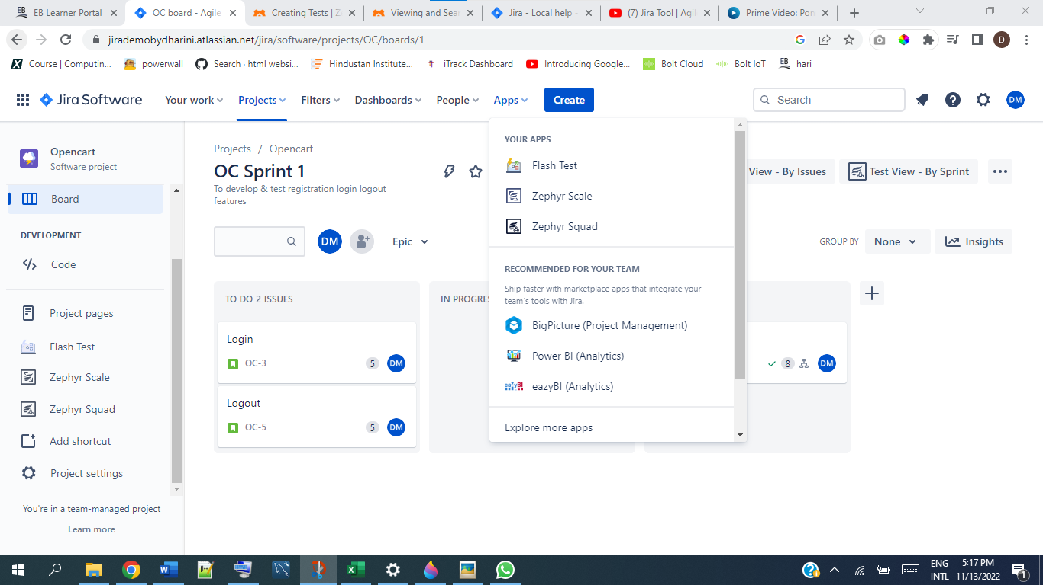

2.how to create testcase in Jira

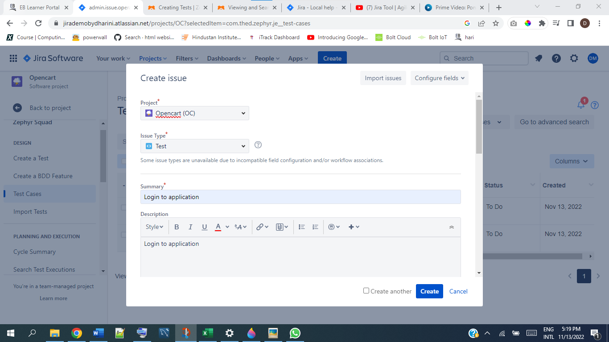

3.How to import multiple testcase into jira tool

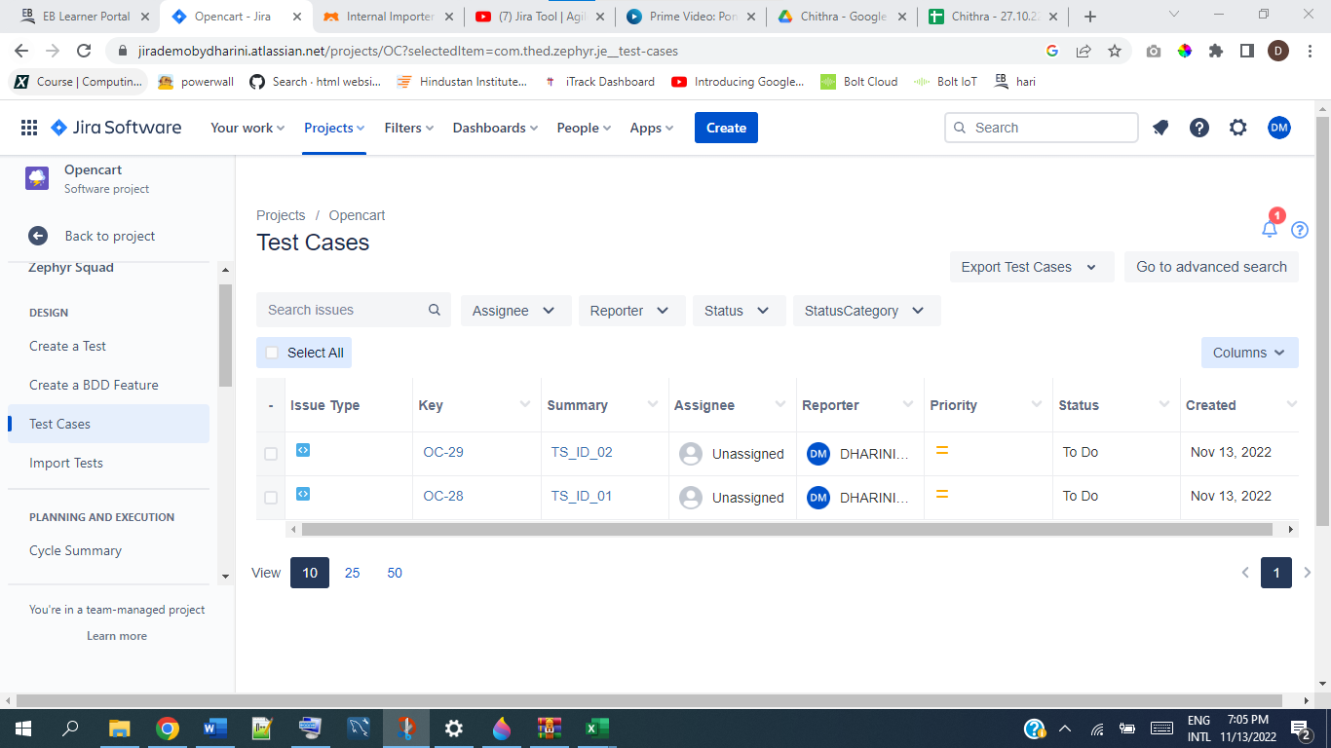

Creating testcase cycles

Add testcases to cycle

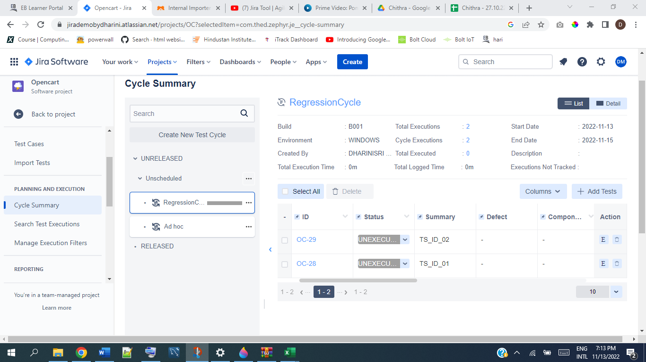

Execute/update testcases

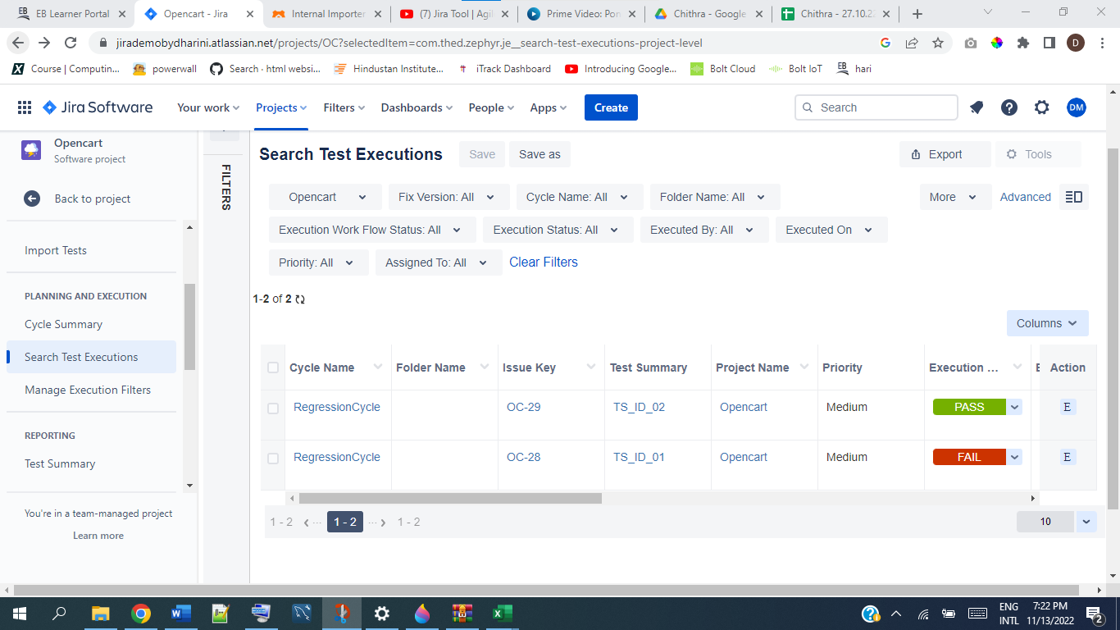

Reporting Bugs

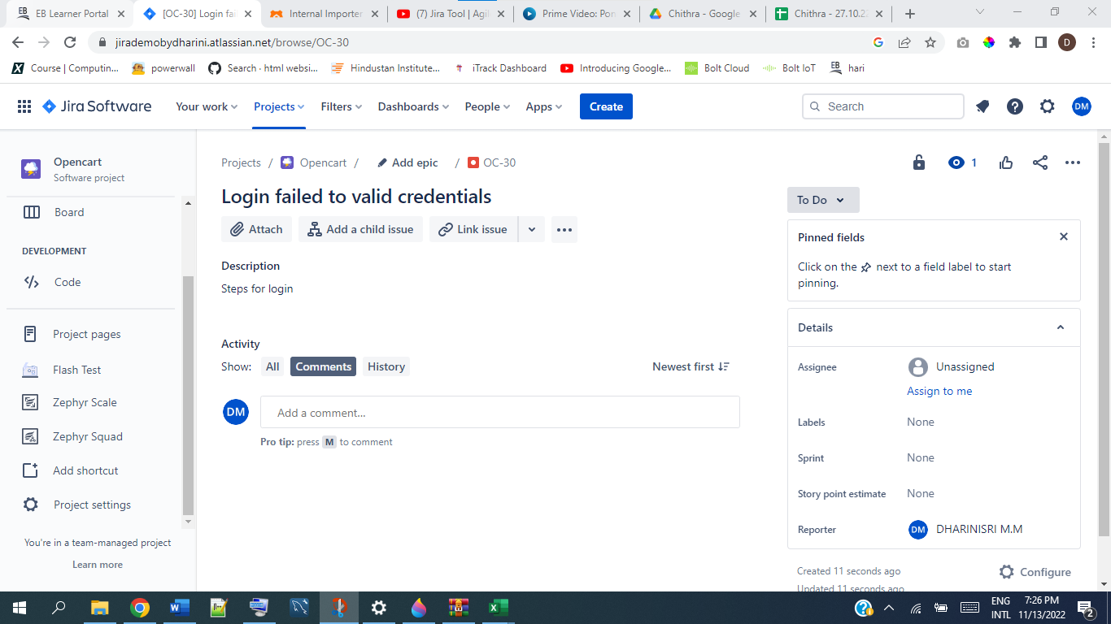

Reports in Zephyr

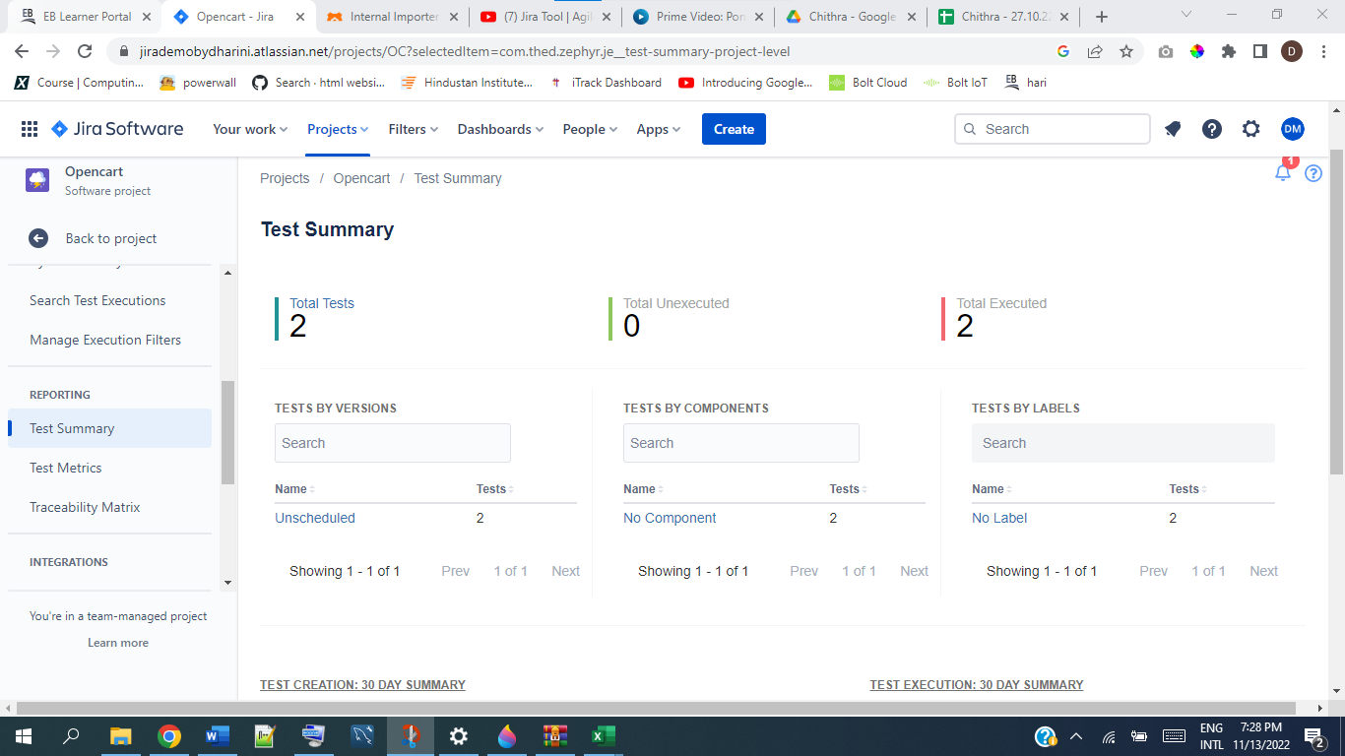

Traceability Matrix

